Exercice A



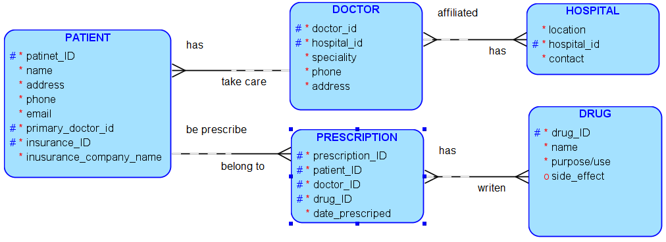





Each PATIENT must have as primary one and only one DOCTOR. Each DOCTOR may take care of one or more PATIENT.
Each DOCTOR may be affiliated to one or more HOSPITAL. Each HOSPITAL must have one or more DOCTOR.
Each PATIENT may been prescribe one or more PRESCRIPTION. Each PRESCRIPTION must belong to one and only one PATIENT.
Each PATIENT may have one and only INSURANCE COMPANY. Each INSURANCE COMPANY must insure one or more PATIENT.
Each PRESCRIPTION must have one and only one PRESCRIPTION_VALIDITY. Each PRESCRIPTION_VALIDITY must belong to one and only one PRESCRIPTION.
Each PRESCRIPTION must have on or more DRUG. Each DRUG may be written for one or more PRESCRIPTION.
Each PRESCRIPTION must have been prescribed by one and only Doctor. Each DOCTOR may prescribe one or more PRESCRIPTION.

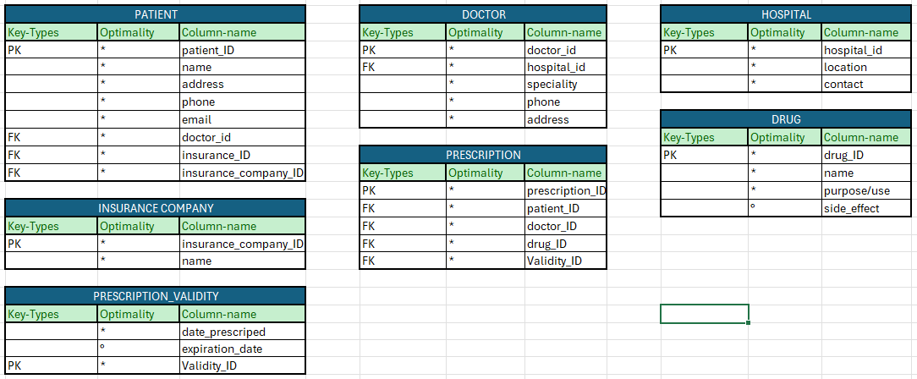

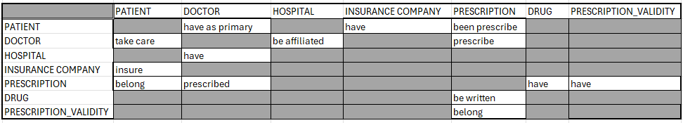
The rest is on paper.

